
Office of Student Life
Saulsbury Campus Center (SCC) Room 232
Phone: (432) 335-6403
Email: studentactivities@odessa.edu

Table of Contents
Office of Student Life Staff 2
Student Life 2
Residence Life 2
Section 1: Recruitment & Involvement Opportunities 2
Section 2: New Student Organizations 2
TYPES OF ORGANIZATIONS 2
ORGANIZATION MISSION STATEMENT 2
CONSTITUTION and BYLAWS 2
Membership 2
Conduct 2
ORGANIZATION ADVISOR INFORMATION 2
Section 3: Initial Registration 2
Section 4: Annual RSO Registration Renewal 2
Section 5: MEETINGS, EVENTS AND ACTIVITIES 2
MEETINGS 2
ORGANIZATION ACTIVITIES and EVENTS 2
Use of Facilities 2
Fundraising 2
Hospitality 2
Section 6: FINANCIAL MANAGEMENT 2
Membership Dues 2
Section 7: RSO STUDENT TRAVEL 2
Section 8: MARKETING INFORMATION 2
Section 9: POSTING POLICY 2

Office of Student Life Staff

Student Life

Executive Director of Student Life……………………….....…………...………….Keagan Scott
(432)335-6403
Director of Student Activities …………………………….…………………….…Elyssa Garcia
(432)335-6313
Student Life Specialist…………………………………….………………………Maria Vazquez
(432)335-6403

Residence Life

Director of Residence Life & Chief Conduct Officer……………………………………Vacant
(432) 335- 6300
Residence Life Coordinator…………………………………...……………………Juan Melchor
(432) 335- 6300

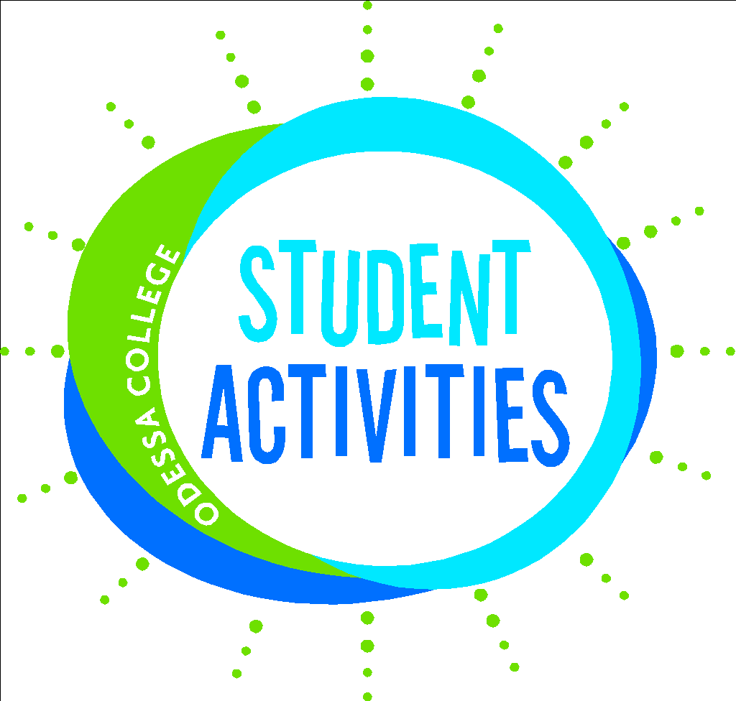

Section 1: Recruitment & Involvement Opportunities

The programs/events listed on this page are involvement and recruitment opportunities for our Odessa College Student Organizations.

Student Government Association
The Student Government Association (SGA) is the governing organization of all Registered Student Organizations (RSOs). It is MANDATORY that each student organization assigns a RSO Representative to be present at each SGA meeting. It is important that your organization representative(s) attend SGA meetings, collaborates with SGA, and hosts student events to receive SGA funding to help support the development of our students.

Wrangler Orientation
The purpose of Wrangler Orientation is to “Wranglerize” our students and assist in their transition into Odessa College. These are designated dates in the summer to give a campus overview, share OC and Community resources, and promote student activities and RSOs to incoming students.

Student Life Q&A’s / Meetings / Trainings
RSO representatives and their advisors are required to attend one Meet and Greet/Question & Answer session and complete the Annual Risk Management and Advisor training on Blackboard each academic year. All events and trainings provide information on RSO forms, funding requests, rules, and regulations. Events and activities are advertised via email to advisors/organization members.

Awareness Programming
Programs may include, but are not limited to Cultural Diversity, Alcohol Awareness, Health/Wellness Awareness, Disability Awareness, and Hispanic and Black History Months. These events are typically held during the Fall and Spring Semesters.

Student Awards of Excellence
This event is held during the Spring semester to recognize our outstanding students. The purpose is to honor outstanding students in the areas of academics, volunteerism, athletics, Registered Student Organizations, and other related areas. Our nomination forms will be sent out via email to OC Faculty and Staff. Advisors should consider nominating their outstanding members. Advisors are encouraged to send the Director of Student Activities their graduating officer names so they can be corded and recognized during the ceremony.
Student Activities Events
Student activities host several free events throughout the year. Some events include Wrangler Round UP, Bingo Nights, Karaoke, Canvas Painting Classes, Mardi Gras parade, Stress Free Events, Homecoming and many others. We encourage all student organizations to be engaged. It is important that your student organization be visible and recruit new members throughout the semester. Student Activities welcomes collaboration with our student organizations, send us your ideas to plan the next big event.

Drive to Success
Drive to Success (DTS) is the ultimate incentive program. Students can earn points while attending events, activities, sporting events, volunteering, and many other engagement opportunities. Student organization members can earn points when they attend officer meetings (2 points) or general organization meetings (2 points). It is highly encouraged that all student organization events promote DTS.

Section 2: New Student Organizations

A Registered Student Organization may be formed at any Odessa College campus with signatures of at least two (2) currently enrolled Odessa College students who wish to operate within the college structure for an expressed purpose and one (1) full time or part time OC employee. The Director of Student Activities, or designee, may make an exception to reduce the minimum member requirement. Organization registration and/or renewal is necessary before the services and facilities of the college campus are available to the organization. An organization must not represent, nor imply, in its contracts with the college community or public that it speaks for, or in the name of, the college or campus.

TYPES OF ORGANIZATIONS
All organizations are overseen by the Office of Student Life. Each organization is made up of Odessa College students who share a common interest that falls into one of the approved categories whose primary activity and/or service is for the college and all students.
- Athletic & Recreation Groups: Dance teams, athletic clubs, and game associations provide members with opportunities to stay active while taking a break from the college routine.
- Service Groups: Volunteer opportunities provide members to make a difference in their community.
- Cultural Groups: Multicultural and international groups.
- Religious Groups: A variety of groups provide campus opportunities for expressing faith and fellowship.
- Academic Groups: Natural extensions of classroom learning. Academic clubs range from campus-based groups to local chapters of national organizations and allow its members to pursue their intellectual curiosity in a variety of disciplines.
- Special Interest and Social Groups: Including student governance, honorary groups, political involvement groups that provide an opportunity for students to stay involved and updated in campus and community activity.

ORGANIZATION MISSION STATEMENT
The mission of the student organization must reflect the values and mission of Odessa College. The Odessa College mission is as follows:
Odessa College shall lead the way in preparing its students and community for the future. The College District offers exemplary courses, programs, and services to assist students in achieving their educational goals and becoming lifelong learners, community builders, and global citizens. Odessa College shall empower its employees to model excellence in their service to students, colleagues, and the community.

CONSTITUTION and BYLAWS
Each student organization must have a constitution and bylaws in order to provide appropriate parameters for an organization to be recognized at Odessa College. Please see the attached sample of Student Organization Constitution and Bylaws for more information in establishing proper documentation. Once you have your constitution and bylaws please email them to studentactivities@odessa.edu.

Membership
Organization membership shall be limited to currently enrolled Odessa College students. To be eligible, a student must be enrolled in at least 3 credit hours at the Odessa College campus where the organization is established. Early college and dual credit students can be part of Odessa College student organizations. To be an active member of the organization, a student must maintain a 2.0 grade point average. Each organization must assign two (2) Registered Student Organization (RSO) Representatives to attend each Student Government Association (SGA) meeting.
SGA meeting information: Dates and Times - TBD

Conduct
Student Organizations, their members and guests are subject to local, state and federal laws, as well as Odessa College’s regulations and the Odessa College Student Code of Conduct. Violations will be handled in accordance with the Student Discipline Code and Due Process Procedures set forth in the Student Code of Conduct. Violations to the Code of Conduct may result in termination of the organization’s registration and/or recognition by the College.
All student organizations must be in accordance with Odessa College policy to comply with all applicable federal and state laws and regulations prohibiting discrimination. Organization membership shall be extended without regard to sex, race, age, religious beliefs, sexual orientation, or disability.

ORGANIZATION ADVISOR INFORMATION
Each organization must select an on-campus advisor who will assist in establishing goals and objectives. It is also important that on-campus advisors assist in planning and developing programs and activities that align with the organization’s goals and mission. The on-campus advisor will initiate requests for expenditures and college services, and will monitor the organization’s account. The on-campus advisor must be an OC employee. An on-campus advisor is required to be at ALL organization events, meetings, executive board meetings, and travel opportunities. Only on-campus advisors can sign off on student organization forms.
If an advising relationship is no longer beneficial to the organization, members should contact the Director of Student Activities to discuss mediation and/or replacement of the organization’s on-campus advisor. Student organization on-campus advisors are required to complete the Mandatory Risk Management and Advisor trainings each academic year. These training models are due no later than 21 days following the student organizations registration or annual registration renewal. All organization on-campus advisors and officers must complete the trainings prior to being able to utilize campus facilities or requesting SGA Funding.

  - Student Organization Advisor Roles
Support and training for organization advisors is available through the Office of Student Life. Feel free to discuss ideas and club issues with the Director of Student Activities. Student Life is supportive of student organizations and is committed to delivering the best experience for organization members. Also, Student Life finds it necessary to foster a community of collaboration to deliver the best college experience. As an advisor you should:
    - INFORM
Serve as an informational resource to help members come together as a group to work together and to accomplish their organization’s goals. The advisor should serve as a communication bridge between the Director of Student Activities, organization members, and OC students.

    - SUPPORT
Provide support and guidance to organization members as they learn how to balance their new roles as student leaders and assist in developing their skills and abilities through activities. Advisors are in a unique position to encourage the development of initiative, responsibility, inclusion, and leadership in the organization’s members.

    - GUIDE
Ensure that organization members understand and properly follow Odessa College policies and procedures when conducting local business. Advisors should also be familiar with the organization’s Constitution and Bylaws. They should also be prepared to help organization members follow and interpret these documents as needed.

    - LISTEN
One of the many purposes of our student organizations is to give students a voice. Listen to the students and help them discover their voice. What are their interests? Their concerns? How can the organization assist them and other students to pursue their interests? What can they do to begin turning their concerns into a positive action?
    - MAINTAIN ACCOUNTABILITY
Students are learning about teamwork, accomplishing goals, and the essentials of running an organization. Support them in maintaining high levels of professionalism, integrity and respect for themselves and others. Help the students learn and practice personal accountability. Accountability includes budgeting, financial controls, attending meetings regularly and following through on tasks.

    - PROVIDE SIGNATURE AUTHORITY
Each organization may establish an organization account through the college to maintain a budget and cash flow. The advisor can work with the organization's officers on maintaining financial records, supervising, financial transactions, and the handling of organization funds. The organization’s advisor has signature authority on organization accounts; two college staff signatures are required for the expenditure of organization funds.

    - REPRESENT THE ODESSA COLLEGE CAMPUS
An advisor has the opportunity to help organization members demonstrate their mission and ideals to the OC campus. It is important that advisors encourage the very best representation of OC. Advisors can play an active role in assisting students to set up a meaningful program that is consistent, inclusive, and welcoming.

    - SUPERVISE
Advisors are responsible for proper supervision of meetings and activities planned by the organization’s members. Experience has shown that most effective campus groups are those whose meetings are regularly attended by advisors. Although the students should be encouraged to provide their own momentum, they still need a guiding hand from time to time. Review and approve organization goals and objectives for submission each year. Work closely with the Director of Student Activities to ensure that all college policies are followed and that all organization activities are communicated to the appropriate authorities.

Section 3: Initial Registration

Students may seek to register an organization at any time as long as they meet the requirements for new student organizations. All students or advisors interested in starting a new student organization should complete the “New Student Organization” form on the Odessa College Website (www.odessa.edu > Current Students > Campus Life > Student Life > Student Organizations).
The creators of the new student organization should complete and submit the following:
- The completed “Odessa College Student Organization Registration” Form
- Attach the new student organizations proposed Constitution AND Bylaws in the above-mentioned form.
- The “RSO Officer Contact List” Form
- On-Campus Advisor must complete and submit the “RSO Advisor Agreement” Form
The recognition process consists of review and approval by the Director of Student Activities and the Executive Director of Student Life. The Director of Student Activities, or designee, will notify the student organization’s advisor in writing of campus recognition when the review process has been completed. The decision of the Director of Student Activities and the Executive Director of Student Life is final. Once the New Student Organization is approved, the Advisor and Organization President will be assigned to the Registered Student Organization (RSO) Blackboard Page. This is where all RSO Forms and Trainings will reside. RSOs are responsible for uploading approved RSO forms to the RSO Blackboard Page when granted access and keeping the documents current throughout the academic year.

Section 4: Annual RSO Registration Renewal

Renewals must be completed at the beginning of each Fall Semester by September 15th. All organizations are required to renew their status once each academic year. Failure to renew your student organization will result in losing privileges as a registered student organization at Odessa College.
When an organization renews their registrations, the following must be completed and submitted:
- The completed “Odessa College Student Organization Registration” Form
- Send the new student organizations proposed Constitution AND Bylaws to studentactivities@odessa.edu.
- The “RSO Officer Contact List” Form
- On-Campus Advisor must complete and submit the “RSO Advisor Agreement” Form

Section 5: MEETINGS, EVENTS AND ACTIVITIES

All forms can be accessed online via the Odessa College Website or Blackboard. These forms include the following:
- Organization Registration/Officer Contact Sheet
- Event Approval Form
- Fundraiser Approval Form
- Service Activity Approval Form
- Travel Approval Forms
- SGA Fund Request Forms

All forms must be submitted via email to studentactivites@odessa.edu
Forms submitted by students, unless otherwise instructed by the Director of Student Activities, will be rejected.

MEETINGS
All student organizations are encouraged to establish a schedule of regular meetings and are required to let the Director of Student Activities know their meeting day/time no later than 3 weeks into each Fall/Spring semester. They should publicize the dates, times, and locations of these meetings. Organization advisors must make room arrangements on their own unless assistance from the Director of Student Activities is requested. MEETINGS SHALL BE OPEN TO ALL INTERESTED MEMBERS of the college community whether or not they are, or intend to be, members of the club.

ORGANIZATION ACTIVITIES and EVENTS
All events must be approved before hosting the event. All forms for event approval must be submitted 3 weeks before the event via Blackboard. Failure to submit an “Event Approval Form” prior to an event will result in a denial of the use of campus facilities for that event and possible loss of recognition as a Registered Student Organization.

Use of Facilities
Only active registered student organizations have access to OC campus facilities. The public spaces of the campus provide excellent space for student outreach, displays, group activities and campus events. The conference rooms near the Office of Student Life and various classrooms can also be reserved for meetings and other organization business. All inquiries and requests regarding the scheduling or use of campus facilities should be made through the appropriate campus office; see the Office of Student Life for specific referrals. Your advisor must also submit a FreshService request to reserve a location on campus. Let the Director of Student Activities know if you need assistance. Locations for general or executive board meetings:
- Saulsbury Campus Center Game Room – reserve with Student Life
- Saulsbury Campus Center Board Conference Room- reserve through FreshService
- Saulsbury Campus Center Conference Room- reserve through FreshService
- LRC Meeting Rooms- reserve through the LRC Staff
- Wood 119- reserve through FreshService

Fundraising
Individuals/Groups may NOT use buildings, properties, and facilities of the college for private or personal gain or for activities in opposition to the college's general educational purposes. With prior authorization, sales on campus are permissible by registered student organizations that desire to earn funds for future endeavors. All fundraising request must be submitted by the On-Campus Advisor at least 3 weeks before the fundraiser via Blackboard. No raffles are allowed on campus or off campus. In general, sales of any kind cannot be held if such sales interfere with normal college activity or with the operation of food services. Always contact the Odessa College Foundations office if your organization is planning a fundraiser at a restaurant.

Hospitality
Great Western Dining is the contracted college food service provider; Great Western Dining has the right of refusal for all events that include bringing outside food. Food can be ordered from their catering menu if chosen. Food is permitted at organization functions and socials. Campus policy on food in classrooms must be adhered to and clean-up is important. To place an order, please call 432-335-6817.

NOTE: IF meeting/event location is not properly cleaned following use, the RSO may be charged for cleaning costs.

Section 6: FINANCIAL MANAGEMENT

Student Organizations can request funds from the Student Government Association (SGA) to alleviate travel costs, for events on campus/off campus, or for general/promotional materials. SGA may approve full amount, half or less of the amount requested. The monies allocated to your organization must be used for travel, events on campus/off campus, materials, or promotional materials. No monies allocated by OC SGA can be used for profit (fundraisers). All organizations can request funds 3 times a year. To receive funding, your student organization must submit the SGA Funding Request Form via Blackboard. All forms can be accessed online via Blackboard and can only be filled out by the student organization advisor. The Director of Student Activities will communicate with your advisor on how to pay for the travel, events on campus/off campus, materials, or promotional materials. SGA members will discuss and decide what the appropriate amount of allocated funds are for each organization per their request. SGA members will consider the following when reviewing requests: SGA General Meeting attendance by RSO, RSO activity and events hosted on campus, and organization involvement with SGA outside of general meeting attendance.

Membership Dues
Student organizations may choose to collect membership dues. Policies for membership dues must be detailed in the organization’s constitution. All members should receive a documented receipt of their payment (i.e. - signed carbon copy, email, etc). Deposits of membership dues should be made within one business day of receipt. It is the organization’s responsibility to keep records of membership applications and dues received from each member.

Section 7: RSO STUDENT TRAVEL

The Director of Student Activities and Vice President of Student Services and Enrollment Management must approve all travel requests pertaining to students. Travel requests should be submitted at least FOUR weeks before scheduled departure. If travel is out-of-state, allow SIX (6) weeks for processing. Traveling outside the State requires permission from the President of Odessa College. All students attending the trip must be organization members. See page 6 for more information on what constitutes an organization member.
Students, as well as district personnel, are responsible for the care and safekeeping of their personal property during trips. In addition, if damages occur during the occupancy of a lodging facility, the student occupants and the student organization will be held financially responsible for any damages incurred to that facility. The college will not be held responsible. All injuries involving Odessa College students should be reported to Campus Police immediately.
A student injured on campus or during a College sponsored activity should be referred to his/her personal physician for necessary medical services. Student will be responsible for all expenses incurred. If the injured student believes the College was negligent and/or the cause of their injury, the student may contact the office of the Vice President of Student Services and Enrollment Management (VPSSEM) to file a liability claim. It is essential to contact the office of Student Life about any planned travel. Forms and assistance are also available on the Student Life website.
- Required Documents for Travel
All travel documents must be submitted at minimum 4 weeks prior to trip.
- Registered Student Organization Travel Proposal Form
- Travel Itinerary
- List of Student Names AND OC ID Numbers
- Signed Liability Form for EACH STUDENT TRAVELING
- OC Trip Approval Form

- Required Documents After Travel
- Post-Event Travel Report (must be submitted by advisor via Blackboard)

- Drivers
- Only approved drivers can drive OC vehicles. To receive approval to drive OC vehicles, visit the OC Police Department to complete paperwork. Note: Applicants driving record will be reviewed so this must be submitted a minimum of four weeks in advance of travel.
- Contact Motor pool to reserve an OC vehicle a minimum of 4 weeks before travel (432-335-6511. The organization will not be allowed to pick up the vehicle without all paper being approved by all necessary departments.

Section 8: MARKETING INFORMATION

Student organizations are encouraged to use available means to publicize their meetings and special events, both on and off campus. The director of Student Activities must approve all organization’s marketing materials. All student organization fliers and advertisements must have a stamp before posting them. Please refer to our posting policy for posting guidelines. Student Organizations can also submit a Creative Services Request for any media/advertising necessary.
Student Activities can assist in paying for your marketing material for meetings, events, and workshops (with prior approval from the Director of Student Activities). If your organization needs assistance with paying for printed materials, please contact the Director of Student Activities at (432) 335-6403 or studentactivities@odessa.edu. All print requests must be sent 4 weeks before the materials are needed.
  - News Media
Please submit all items to be publicized by Odessa College media outlets a minimum of one month prior to publication. Any items that your organization would like advertised in District Publications are to be submitted to the Director of Student Activities via email - studentactivities@odessa.edu. Before submitting news items or announcements, consult with the Director of Student Activities regarding the proper protocol for media coverage. Requests for News items/announcements should include:
- Organization Name
- The title of the event
- Dates, times, locations
- What is the purpose of the event
- How it will benefit students? How will it benefit the college?
- Point of contact

  - Social Media Guidelines

Student organizations are not allowed to create a Facebook page, Instagram page, Twitter account, You Tube channel, or any other form of social media for their organization. This is a requirement by our OC Marketing and Media Relations. Student Activities encourages your organization to use social media responsibly and to connect with members, publicize events and improve communication through Student Activities and Student Activities Social Media Accounts. If your organization would like to post on social media, contact the Director of Student Activities or OC Marketing and Media Relations.

Section 9: POSTING POLICY

In our efforts to maintain an orderly campus environment free of clutter, the following posting policy shall apply:
  - All postings MUST be approved through the Office of Student Life. Posted items with an official stamp must be stamped and dated with the posting date. Organization postings may not remain posted in excess of one semester. Exceptions may be made by special permission from the Director of Student Activities.
  - Automobile windshield flyers and any auto-postings are prohibited.
  - Organization members will be responsible for obtaining permission, posting, and removing flyers in a timely manner. Flyers advertising an event or activity must be removed by no later than 5:00 PM the following day.
  - Student Activities has funding and printing material. Submit a printing request to studentactivities@odessa.edu.
  - Any material posted in an inappropriate place (i.e. walls, windows, etc.) shall be removed immediately. Student organizations can lose their posting privileges if they do not abide by the posting policy.
  - No posting on glass doors
  - No boxing tape or masking tape allowed! Acceptable adhesives include Scotch Tape, poster adhesive tabs, non-visible painters tape (painters table must not be visible – must be rolled and hidden between the wall and poster).
  - Make sure all flyers and posters are displayed neatly and taped on all four corners ALONG the paper. DO NOT TAPE ACROSS THE CORNERS – THIS IS SLOPPY AND NOT ACCEPTABLE.
  - Make sure to post in high traffic areas such as Foyers/entrances
  - Do NOT post materials at the Sports Center or LRC. Deliver your materials to their reception staff and THEY will post them in the appropriate locations.

